
Profield Chat-v2.0
Software Requirement Specification
Revision History
Version | Author | Date | Remarks
2.0 | Midhun KC | 14-05-2020 | 1.0.0.20181020

Software Requirement specification for Profield Chat Application.

Table of Contents
1 Introduction 5
1.1 Purpose 5
1.2 Scope 5
1.3 Product / System Overview 5
1.4 User Characteristics 6
2 Functional Requirements (Web /IOS) 6
2.1 User Sign up 6
2.2 User Reactivation 6
2.3 User Login 7
2.4 Product List 7
2.5 Recent Chat History 7
2.6 View More Functionality 7
2.7 Text Chat 7
2.8 Emoji Support in Chat 7
2.9 Attachment Support 7
2.10 Voice to Text support 8
2.11 Voice chat support 8
2.12 Delete Message 8
2.13 Reply Message 8
2.14 User Delete/Deregistration 8
2.15 Change Password 9
2.16 Forgot Password 9
2.17 User profile update 9
2.18 User Feedback 9
2.19 User Logout 9
2.20 Show online/offline status of the user 9
3 Functional Requirements (ADMIN MODULE) 9
3.1 Admin User Login 9
3.2 Admin User Logout 9
3.3 Change Password 9
3.4 Search and List Category 9
3.5 Create New Category 10
3.6 Edit Category 10
3.7 Delete Category 10
3.8 Search and List Product 10
3.9 Create New Product 10
3.10 Edit Product 10
3.11 Delete Product 10
3.12 Search and List Product Owners 10
3.13 Create New Product Owner 10
3.14 Edit Product Owner Profile 11
3.15 Delete Product Owner 11
3.16 Delete Product Owner Messages 11
3.17 Search and List Customers 11
3.18 Create New Customer 11
3.19 Edit Customer Profile 11
3.20 Delete/Deactivate a customer 11
3.21 Delete Customer Messages 11
3.22 View Chat Functionality 12
3.23 Delete Messages in View Chat 12
4 Non-Functional Requirements 13
4.1 Performance Requirements 13
4.2 Security Requirements 13
4.3 Software System Attributes 13
5 External Interface Requirements 14
5.1 User Interfaces 14
Login Page 14
New User Sign-up Page 14
Customer Side Chat Page 15
Product Owner Side Chat Page 15
View More Functionality 16
Web Customer Home Page 16
Edit Profile Page 17
5.2 Hardware Interfaces 17
5.3 Software Interfaces 18
5.4 Communication Interfaces 18
6 Acceptance Criteria 18
7 Appendices 18

Introduction

Purpose

The purpose of this document is to present a detailed description of theProfield Chat Application version 2. Description includes the purpose and features of the system, the interfaces of the system, the operations in the system and the constraints under which it must operate. This document is intended for both customers and developers of the system and shallbe reviewed and approved by the customer, before proceeding with development of the system.

Scope

This system will be a customer supporting Chat Application System for Profield Corporation in Japan. The Chat system will be allow. The purpose of the customer supporting chat application is to allow users be able to the chat with each product owner, like a normal chat application. The users will be able to chat with each other privately ie; 'between customer and product owner' but all the chat will be monitored by the admin at everytime.The chat should allow to send and receive voice messages, voice to text messages and also able to send attachments. The user configuration and the actual chat messages should be stored in a database.

Product / System Overview
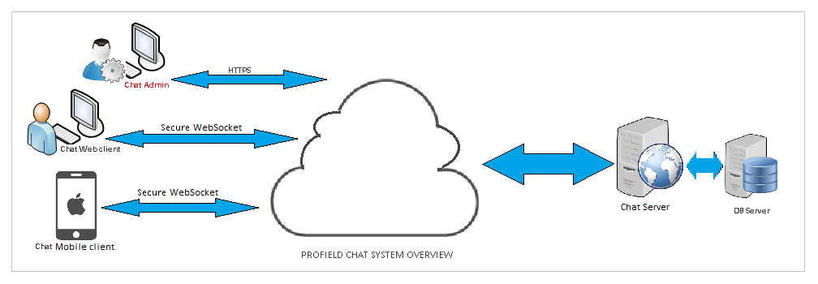
The overview of the chat system is consists of
- A responsive web client(which supports Mobile view) which will allow users to login to the chat application and chat with the product owners.
- A native IOS mobile app, is very easy to use, provides instant access to product owners and chat messages.
- An Admin web application, allows a admin user to manage the user,product owner and products in the appliaction.
- A Chat Web Server, provides the services to the clients and admin module

User Characteristics

There are three types of users in the chat system:
- Admin user: This user have access into the Admin module of the customer supporting chat application. Admin user can manage normal users of chat, product owners and product with in the application.
- Normal Users: These are the general users of chat application, will be anyone who is a registered user of chat.
- Product Owners : This user is generated by admin user and they can chat with normal users.

Functional Requirements (Web /IOS)
The functionality of the chat application is to give the ability to chat user with product owner whoever is online on the application.
There are two chat clients, a web application and an IOS app. Both clients will allow users to connect with other users and chat.

User Sign up
There is a sign up module through which anyone can register as a chat user. Username and email will be unique for a user, other details such as first name, last name and profile image will be accepted here.On registration an email will be sent to the user with a login URL. The product owner is created by the admin itself and the username and email will be also unique for every user and product owner.

User Reactivation
On sign up, if a deleted user record found with the same email (provided by the sign up user), user will be prompted with a confirmation message for reactivating the account. On confirmation, the delete flag will be removed and the user account will be active. All the messages belongs to the previous user session will be deleted permanently. A notification email will be sent to the user regarding the account reactivation event. If the user wants to reset the password, he/she would use the ‘Forgot Password’ option provided in the login page. Product owner reactivation is simple procedure, the admin can reactivate him/her through admin panel.

User Login
A registered user can login into the chat application. After login, the chat home will be displayed with user’s contact list, and the user will be online in the contact list of his/her friends.
In IOS app, it will keep the user, unless we manually logout of the chat app. In Web application, for each time when we login a user session will be created and it will be invalidate, if the user is logout manually from chat. The session does not check the user's inactive time here.
The product owner also logs in the same way as the users.

product list
User have the multiple list of products within the customer support chat application.In this list of products,every products have one or more product owners and the user can chat with this product owners by clicking the product.

recent chat history
The user scan easily find the latest five chat history of the user with in the application.

view more functionality
Within each chat window of customer or the Product Owner, there is a view more functionality to get more details of the product they are chatting about.

Text Chat
A user would be allowed to send and receive text messages it will instantly notified to the receiver, if that user is online. If not the messages will be stored in database and when next time when the user comes online, this will be notified.

Emoji support in chat
A user would be allowed to send and receive emoji icons.

Attachment support
A user would be allowed to upload and send a file as attachment message and this will be notified to the receiver immediately. If the receiver is offline, it would be notified whenever he/she come online next time.
Attachment file types would support popular text formats, document formats, image formats, audio and video formats and some specialized formats of Adobe tools.
- PDF, TXT, DOC, DOCX, XLS, XLSX, PPT, PPTX
- JPEG, PNG,GIF,TIFF,ICO
- MP2, MP3, MP4, MOV
- EPS, AI, INDD

Voice to Text support
A user would be allowed to record a voice message and it would be converted into its corresponding Japanese text, and then send as a text message.
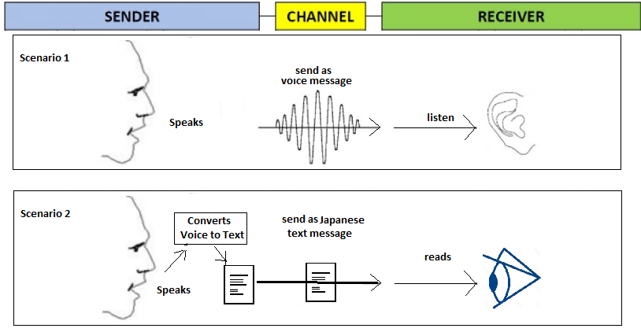

Voice chat support
A user would be allowed to record a voice message and send as a voice message to the receiver. If the receiver is not online, it would be notified whenever he/she come online next time.

Delete Message
A user would be allowed to delete a message, if he is the sender of the message. The messages are not deleted permanently from database, it is marked as deleted with a flag, so it is displayed as a deleted message, instead of showing the actual message text. The admin can see every actual deleted messages in admin panel and these messages should be in color varience for identifying the deleted messages.

reply message
A user / product owner can reply to all his chat messages. Attachments, text and voice messages can also be sent as a reply message.

User Delete/Deregistration
A user would be allowed to do self-deregistration/delete his profile. This will mark that users profile as deleted. This user will removed from the contact list of all his friends. All his messages will be marked as deleted.

Change Password
A logged in user would be allowed to do change his password. He/she will be asked to provide the current password, then the new password and a confirm password. This will sent a notification email to that user.

Forgot Password
Whenever a user lost his password, he/she would be allowed to reset his/her password. The user should confirm his email, so that he/she should receive an authorization token by email. This would accept before resetting his/her password. A notification email will be sent to the user regarding the resetting password event.

User profile update
A user is allowed to update his profile details and profile image. All his/her online contacts will be immediately show the updated profile image/details. Username and email should not be altered.

feedback
User can provide feedback for each chat. This feedback can only be viewed by the admin user.

User Logout
A user is allowed to logout from the application. This will set the user as Offline in the contact list of his/her friends immediately.

Show online/offline status of the user
The contact list should show the online/offline status the user. A change in status should be reflected immediately in the contact list.

Functional Requirements (ADMIN MODULE)

Admin User Login
An admin user can login into the admin module. After login, the admin module home will be displayed with user listing.

Admin User Logout
The admin user is allowed to logout from the admin module.

Change Password
Admin user would be allowed to change his/her password. He/she will be asked to provide the current password, then the new password and a confirm password.

Search and List CATEGORY
In the home page, a category listing will be displayed by default, with pagination enabled. Admin user should be allowed to search category based on category name. Any changes in the category details such as new category addition, category updation or category deletion will be reflected in the category list.

Create New CATEGORY
Admin user would be allowed to create new category, with the categoryname .

Edit CATEGORY
Admin user would be allowed to modify a category’s data. Any modification in the category details would be reflected in the chat clients product listing page.

Delete a CATEGORY
Admin user would be allowed to delete a category.If the category is linked with other products in the product listing page then the category cannot be deleted until the product is deleted. In the database this category record is marked as deleted, and not a hard deletion.

search and list product
In the home page, a product listing will be displayed, with pagination enabled. Admin user should be allowed to search product based on product name and category. Any changes in the product details such as new product addition, product updation or product deletion will be reflected in the product list.

create new product
Only the admin user would be allowed to create a new product with the productname, product title, category of product,product image, available since and expiry on.Every product have at least one product attribute and the product attribute must conatains product attribute title, product attribute description and the product attribute image.

edit product
Admin user would be allowed to modify a product’s data. Every data with in the product can be edit and any modification in the product details would be reflected in the chat clients product listing page.

delete a product
Admin user would be allowed to delete a product.At the time of deletion,If there have any customers chat with this product’s product owner, then the customer and product owner will get the notification about the product deletion and then they cannot chat each other under that product. In the database this product record is marked as deleted, and not a hard deletion.

search and list product owners
In the home page, a product owner listing will be displayed, with pagination enabled. Admin user should be allowed to search product owners based on product owners username. Any changes in the product owner details such as new product owner addition, product owner updation or product owner deletion will be reflected in the product owner list.

create new product owner
Only the admin user would be allowed to create a new product owner with the Firstname, Lastname, gender,username,email id,porfile imageand passwords.Every product owner have at least one linked product with him/her. On creation product owner will be sent a notification email with the login URL of chat application.

edit product owner profile
Admin user would be allowed to modify a product owner’s profile data. Username and email would not be modified. Linked products can be changed for each product owner and we can also add linked products. Any modification in the user account details would be reflected in the chat clients immediately.

delete product owner
Admin user would be allowed to delete a product owner.At the time of deletion,If there have any customers chat with this product owner, then the customer will get the notification about the product owner’s deletion and then they cannot chat each other. In the database this product owner record is marked as deleted, and not a hard deletion.

Delete product owner messages
Admin user would be allowed to delete all messages send by a product owner. This is a soft deletion.

search and list customers
In the home page, a customer listing will be displayed, with pagination enabled. Admin user should be allowed to search customers based on customers username. Any changes in the customer details such as new customer addition, customer updation or customer deletion will be reflected in the customers list.

create new customer
Admin user would be allowed to create new user, with the username, email, first name, last name,gender and his/her password. On creation user will be sent a notification email with the login URL of chat application.

edit customer profile
Admin user would be allowed to modify a customer’s profile data. Username and email would not be modified. Any modification in the customer account details would be reflected in the chat clients immediately.

Delete/ de activate a customer
Admin user would be allowed to delete/deactivate a customer. Any modification in the customer account details would be reflected in the chat, all the deactivated customers contact list will be updated immediately. In the database this customer record is marked as deleted, and not a hard deletion.

delete customer messages
Admin user would be allowed to delete all messages send by a user. This is a soft deletion.

view chat functionality
Admin user can see every chat of every customers and product owners . In the view chat tab, there admin can select a product with a category and it may be deleted or not. Under this product, every chat under this product can be see by the admin.When admin click on the view chat tab, first he can see the product list and by selecting the any of product in the list,there have cutomers list under this product. From these customers we can see the chat history with the feedback they are given. The deleted messages by the customers and product owner can also be see by the admin by color varience in that message.He can also see the last feedback of the customer in every customers chat window.

Delete Message in view chat
Admin user would be allowed to delete all messages under a product and a customers message under a particular product too. This is a soft deletion.

Non-Functional Requirements
The developed chat system should support the following:
- The communication between chat server and clients should be secured
- Should not store the password or similar key details in a readable or decodable form
- The chat system should be capable of sufficiently large number of participants
.

Performance Requirements
The developed chat system should support the following:
- The messages should reach the receiver instantly, without any time delay/lag
- The voice to text conversion should work with an acceptable delay

Security Requirements
The communication between the users should be secured.
The user passwords saved in the database should not be in a readable format.

Software System Attributes

Not Applicable.

External Interface Requirements

User Interfaces

Login Page
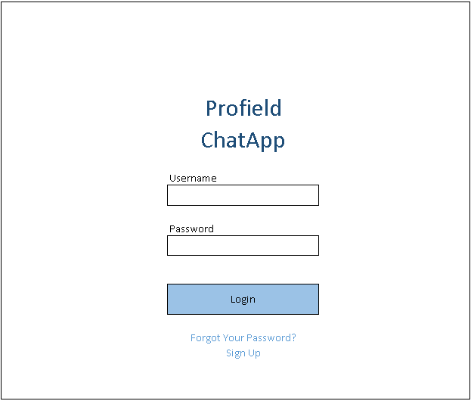

New User Sign-up Page
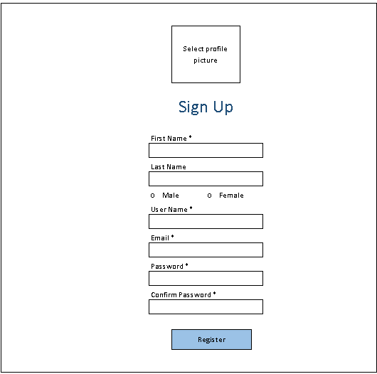
Customer Side Chat Page
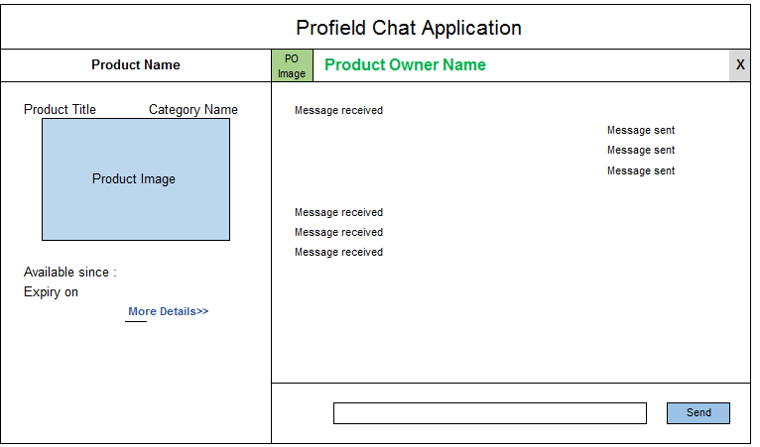
Product Owner Side Chat page
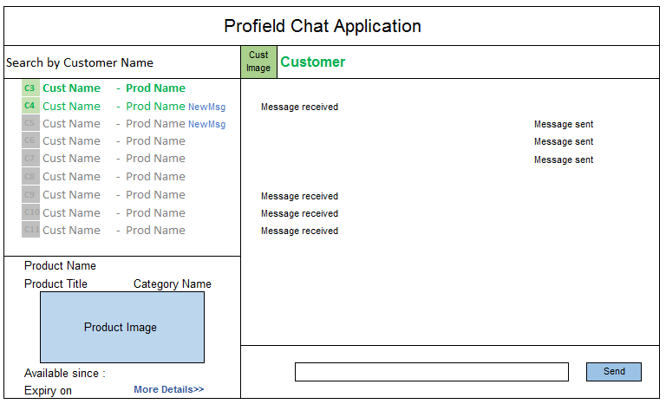
View More Functionality
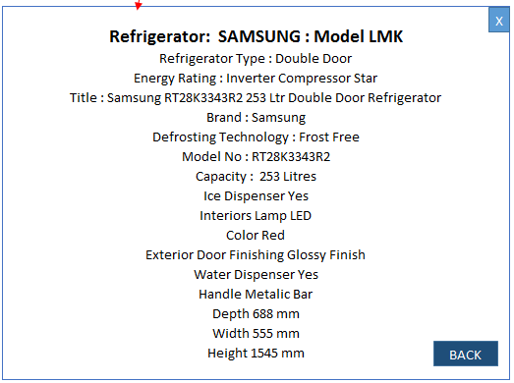

Web customer Home Page
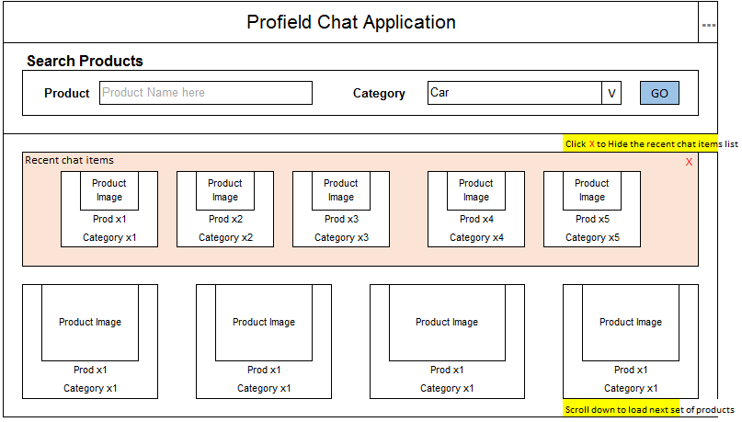

Edit Profile Page
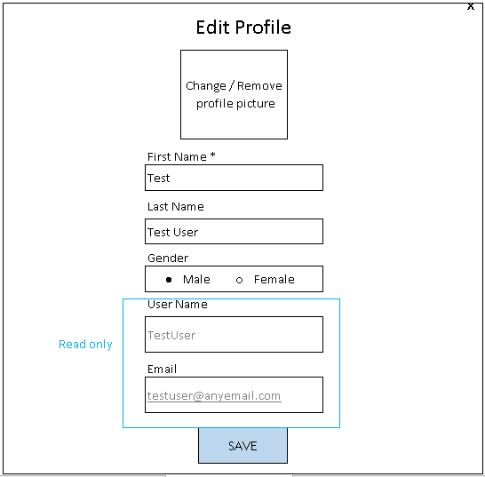

Hardware Interfaces
Not Applicable

Software Interfaces

Operating System : Linux CentOS7.6 (7-6.1810.2.el7.centos.x86_64)
Development Platform
Web application : Eclipse OxygenJava8, Spring Boot 2.0.8
Admin module : Eclipse OxygenJava8, Angular JS v1.9
IOS app : XCode 10.3, Swift 4
Mongo DB versions : 3.4.19
Third Party Tools : Google API (Voice to text conversion)
Recorder.js (Voice recording)

Communication Interfaces
For each chat user, a websocket endpoint is created, with the unique id for each chat user.
All websocket communication is using the endpoint \socket
IOS client is accessing the chat functionality using the end point \api

Acceptance Criteria

Acceptance criteria are based on the submission of demo on each completion stage and final submission of the Integrated Tested Application.
- Voice chat message and Voice to text message should be working as per the industry standard
- All user requirements should work as per the industry standard

Appendices
Not Applicable

